Resources

Everything AA App
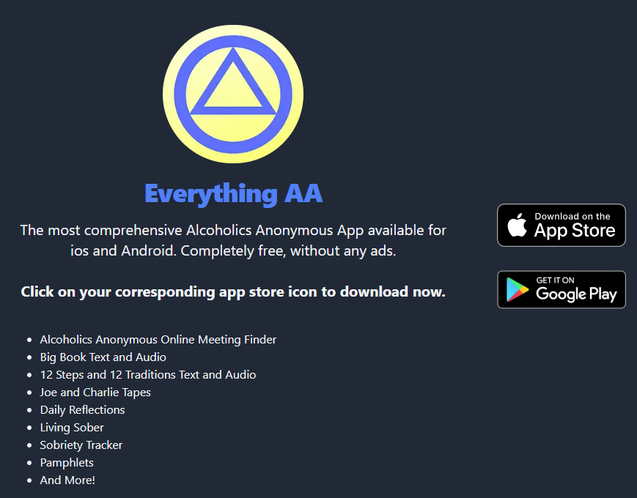
App Store: https://apps.apple.com/us/app/everything-aa/id1565768051
Google Play: https://play.google.com/store/apps/details?id=com.bigbook3

https://www.goodrx.com/conditions/substance-use-disorder/mobile-apps-for-managing-substance-use?srsltid=AfmBOoqmJiCZXHyQR0Ja16NpDsChS6yE5nsIfopaHsYaNaeq5GVOMOrd

https://www.therecoveryvillage.com/drug-addiction/sobriety-addiction-apps/

